**PROGRAMME XO MIGRATION TO VERIZON**

**PROJECT MIGRATION OF SNM LITE**

**APPLICATION TO LINUX PLATFORM FROM SOLARIS**

**DRAFT PROOF OF CONCEPT**

**Document Revision History**

|  |  |  |  |  |  |
| --- | --- | --- | --- | --- | --- |
| **S.no.** | **Version No.** | **Date** | **Author** | **Approval by** | **Remarks** |
| 1 | 0.1 | 03 Jul 17 | Prasanna V A |  | Initial version |
|  |  |  |  |  |  |
|  |  |  |  |  |  |
|  |  |  |  |  |  |
|  |  |  |  |  |  |

Table of contents

1. Executive Summary 4

2. Aim 4

3. Background 4

4. Project Overview and Key Efforts 4

5. Scope Initiative 6

6. Goals and Objectives 7

7. Constraints 9

8. Lessons Learned 9

9. Recommendations and Approval 9

10. Appendices 9

# Executive Summary

# Aim

The aim of this document is to assess, plan, develop , evaluate ,deploy and support implementation of the SNM Lite Application Migration from Solaris to Linux Platform.

# Background

The SNM Lite application is used as proxy to utilize the SNM/IPSM Application server at US Site for logical provisioning in the Indian customer while masking the customer data as per the norms of GoI Security Compliance through Indian Servers present at Chennai and Mumbai as redundant for DR. The SNM Lite Application has its own Application Container and database with replications to the relevant Data compliance achieved through masking the data to GoI Standards requirements. The SNM Lite http session redirections to US Main SNM/IPSM Application Server are achieved through Apache Reverse Proxy Servers.

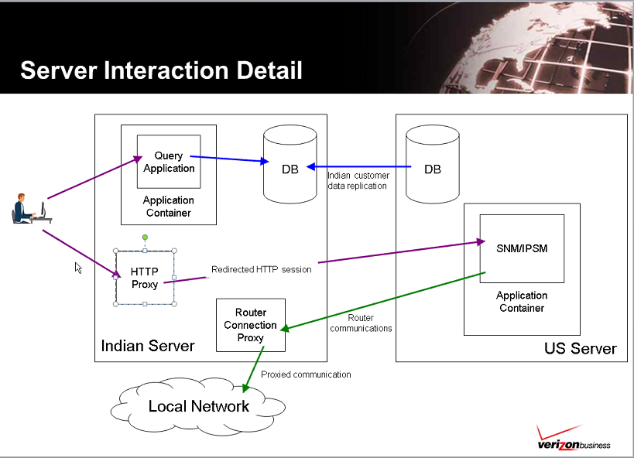

# Project Overview and Key Efforts

The following diagram exhibits the current setup of SNM Lite Application which depicts the high level solution of current application which operates on Solaris OS Platform which needs to be migrated to Linux OS Platform.

The components of applications are broadly segregated as follows :-

1. Oracle Database running on existing on both primary and secondary located at Chennai and Mumbai getting synced at regular intervals to meet Data integrity at DB Level
2. Oracle Iplanet Weblogic Server for the application container
3. Apache Proxy Server setup
4. Hardware Build Configurations
5. SNM Lite Source Application Code
6. Git repository integration
7. Primary/Secondary activation
8. Local and External Network Integration and Device Configurations
9. Firewall Configurations/ACL requirements
10. OS Level Configuration requirements for the Applications/System Performance/Compliance

The above is the production setup and there is no other Dev/QA/UAT systems available currently. The current setup acts with a Primary and Secondary site which is activated through url (Applications used needs to be defined).

The database at Indian site is synchronized with the relevant data of US SNM/IPSM Database through DB Features (such as GoldenGate/Stream/Scripts clearly not known/defined) with a target update delay of less than five minutes. The replications between Indian DB i.e primary and secondary servers are achieved in near real time. The

The Application source code is maintained as common at Git repository for both the servers for integrity. The codes are not modified for long time as there was no requirement in past. For any updates on the Application/System , the secondary server is used to test for production after verification/review through the local build server which is also decommissioned.

The CI/CD part of the components of current setup is not known apart from Git repository and needs to get clarified if existing as well as future requirements in respect of OS Configurations, Application /Proxy server configurations.

The above application setup is under compliance of GoI Standards which needs to be understood/provided by the Client.

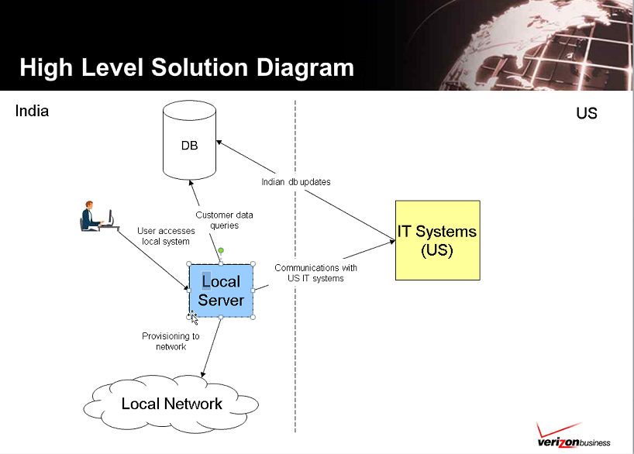

# Scope Initiative

The scope of this initiative is to transform/migrate the existing SNM Lite Applications which includes Apache Proxy, Iplanet Web App Server and Oracle Database on Solaris OS Platform to Linux OS Platform end to end as per existing performance guidelines to be assessed/provided and form a Scope Baseline.

SCOPE IN –To be defined after assessment.

SCOPE OUT – To be defined after assessment.

# Goals and Objectives

The Goals and Objectives are defined to migrate two servers of SNM Lite Application Components from Solaris OS Platform to Linux Platform based out of India to achieve the targeted results that is after Migration to Linux Platform, the SNM Lite application is expected to run as per the as-is environment performance metrics of the current operations through proper life cycle of to Assess , Plan , Develop, Evaluate, Deploy and Support on Agile principles.

* 1. **Assess**
     1. Identify Stakeholders
     2. Assess for Envrionmental Setup and Operational Access requirements
     3. Assess Configurational Setup in Applications for ISV, Custom and Opensource
     4. Identify the performance metrics for Comparatitive analysis
     5. Assess the Current OS Platform Configurations and Setup for To-Be
     6. Assess the HW Setup and requirements for To-be
     7. Assess the Compatibility pertaining to HW and Applications for target Platform
     8. Assess the Vendor support if any.
     9. Assess the known issues on Current Platform
     10. Assess Network requirements
     11. Assess the requirements for Security Standards compliance for Verizon/GoI
     12. Assess the requirements for Integration with other Applications/Servers/Devices
     13. Assess the OS Installation requirements
     14. Assess the Disks and File Systems
     15. Assess the Software Management
     16. Assess the Device Management
     17. Assess the OS Resources Management
     18. Assess the Boot and Initialization
     19. Assess the users and Groups
     20. Assess the requirements of Monitoring and Reporting
     21. Assess the Backup and Restore of System and Applications
     22. Assess the CI /CD for both system and Applications
     23. Assess Porting Considerations for Apache Reverse Proxy Server
     24. Assess Porting Considerations for Oracle Database
     25. Assess Porting Considerations for Iplanet Web Applications Server
     26. Assess the Risk and Mitigation/Aversion
     27. Assess any requirements for Procurement
     28. Assess leveraging new Technologies/Automation
     29. Assess upgrade/patch update integrations
     30. Assess Ansible Tower Integration if any
     31. Assess libraries and Compilers
     32. Assess the 32bit vs 64 bit Applications for portability
     33. Assess the Shell/Perl scripts transformation
     34. Assess the Big Indian and Little Indian Issues if any
     35. Assess the Scheduled Jobs if any .
     36. Assess for any additional resources
     37. Assess Migration Strategy/Platforms
     38. Submit the Assessment and Scope Baseline for approval after evaluation.
  2. **Plan**
     1. Preparation of Solution Design and Strategy/WBS for approvals.
     2. Design the Prototype Strategy
     3. Design the Production Strategy with Backup and restore plan.
  3. **Develop**
     1. Develop the Prototype as per Solution Design Document/WBS
     2. Develop the Production box for Deployment
  4. **Evaluation and Findings**
     1. Evaluation of Assessment Metrics and submit findings for approval.
     2. Evaluation of Solution Design Document/ WBS if any
     3. Evaluation of Prototype through Comparatitive Analysis.
     4. Evaluation of Production Deployment through Comparatitive analysis
     5. Evaluation of Deployment Plan
     6. Evaluation of Deployment
  5. **Recommendations and Final Decisions**
  6. **Deploy**
     1. Deployment of Prototype
     2. Deployment of Production
  7. **Support**

# Constraints

# Lessons Learned

|  |  |  |  |  |  |  |
| --- | --- | --- | --- | --- | --- | --- |
| Date | Issue | Impact | Platform | Best Practice | Implementation  Status |  |
|  |  |  |  |  |  |  |

# Recommendations and Approval

# Appendices